SELECT Customers.CustomerID, Customers.CustFirstName || ' ' || Customers.CustLastName,
StyleName, (SELECT COUNT(*)
FROM Musical_Preferences AS MP
WHERE MP.CustomerID = Customers.CustomerID)
AS Preferences
FROM Customers INNER JOIN Musical_Preferences
ON Customers.CustomerID = Musical_Preferences.CustomerID
INNER JOIN Musical_Styles
ON Musical_Styles.StyleID = Musical_Preferences.StyleID
;

-------------------------------------------------

--The above query can be also be performed in this manner:

SELECT C.CustomerID, C.CustFirstName || ' ' || C.CustLastName
AS Customer,
COUNT(*) AS Preferences
FROM Customers AS C
INNER JOIN Musical_Preferences AS MP
ON MP.CustomerID = C.CustomerID
GROUP BY C.CustFirstName, C.CustLastName, C.CustomerID
;

-----------------------------------------------

-- The key difference between GROUP BY and OVER() is that GROUP BY applies aggregations across the
-- entire query, rolling-up the specified non-aggregate fields, thus usually reducing the number of
-- returned fields.
-- With OVER(), the same number for rows will be returned as the base query. Any aggreagtions will be
-- returned for each row in the range identified in the OVER() clause.

-- Predicates used: PARTITION BY, ORDER BY, ROWS (or RANGE)

-------------------------------------------------
SELECT C.CustomerID,
C.CustFirstName || ' ' || C.CustLastName AS Customer,
MS.StyleName,
COUNT(*) OVER(
PARTITION BY C.CustomerID)
AS Preferences
FROM Customers AS C
INNER JOIN Musical_Preferences AS MP
ON MP.CustomerID = C.CustomerID
INNER JOIN Musical_Styles AS MS
ON MS.StyleID = MP.StyleID
;

Partial Output:
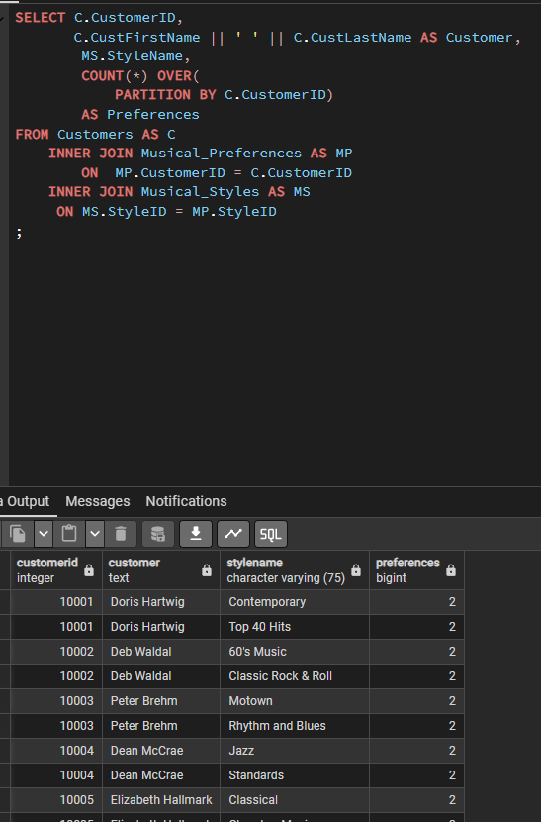
Another Example:

